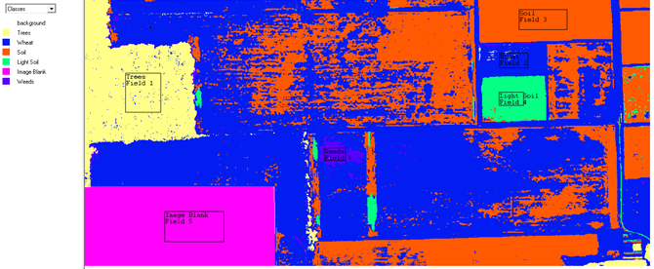

Image Blank

Light soil

Background

Soil

Weeds

Wheat

Trees